Searching Organic Signatures on Mars (SOS-Mars, PID2020-119412RJ-I00)
The presence of hydrated minerals and the valley networks identified on Mars revealed the existence of ancient aqueous habitable environments in the past of this planet (from late Noachian to early Hesperian, 3.9-3.6 Gyrs). In the present day, the surface of Mars is covered by an oxidized regolith that receives high doses of irradiation because of its thin atmosphere. Under this context, the preservation of biosignatures is only possible within mineral matrixes, protected from inhospitable external conditions.
Smectites, hydrated minerals widely identified on Mars's Surface, are key minerals to identify habitable periods in Early Mars as they are related to supergene processes. These phyllosilicates (type 2:1) have a swelling capacity able to adsorb simple molecules in their interlayer space and have proven to be good organic preservers under Mars-like Surface conditions. On Earth, the greatest reservoirs of dissolved organic carbon are related to smectite-rich layers. On Mars, the study of these minerals is one of the main goals of Mars2020 and ExoMars missions, which are focused on the search for extinct life. Indeed, the landing places of both missions (i.e., Jezero Crater and Oxia Planum) have sedimentary units rich in smectites.

Objective
The main goal of the SOS-Mars Project is to provide information about the sedimentary mineral sequences more likely to contain biosignatures. In order to do that, we are investigating the capacity of preservation of several smectites after exposing them to extreme alteration conditions (e.g., Mars-like UV irradiation or percolation of highly oxidizing fluids). Then, we are going to infer what mineral sequences might contain these target smectite by using geochemical models to later generate and characterize laboratory analogs of these minerals sequences.

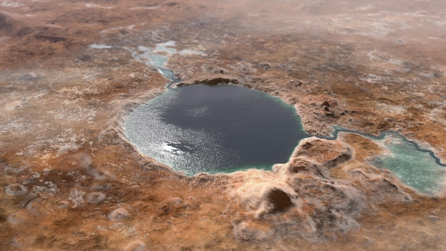 | 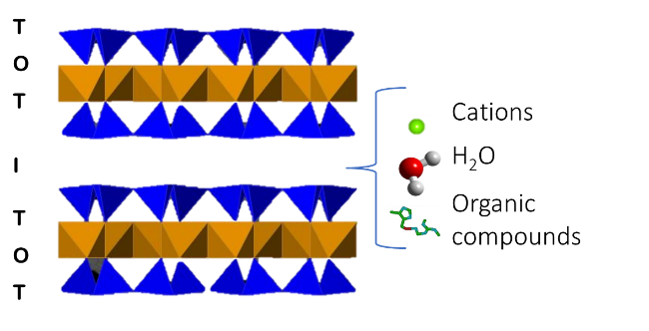
Illustration of Jezero Crater, simulating a lake environment in early Mars. Credit: NASA/JPL-Caltech | Schematic representation of smectites

Team members
Universidade de Vigo: Carolina Gil Lozano (IP), Luis Gago-Duport, Paula Diz.
Centro de Astrobiología (CAB): Victoria Muñoz Iglesias.
Laboratoire de Planétologie et Géodynamique (LPG): Nicolas Mangold, Anne Gaudin.
Istituto Nazionale di Astrofisica (INAF): Teresa Fornaro.

Related publications
Gil-Lozano, C., Fairén, A.G., Muñoz-Iglesias, V., Fernández-Sampedro, M., Prieto-Ballesteros, O., Gago-Duport, L., Losa-Adams, E., Carrizo, D., Bishop, J.L., Fornaro, T., Mateo-Martí, E. (2020) Constraining the preservation of organic compounds in Mars analog nontronites after exposure to acid and alkaline fluids. Scientific Reports 10, 15097.
Losa-Adams, E., Gil-Lozano, C., Fairén, A.G., Bishop, J.L., Rampe, E.B., Gago-Duport, L. (2021) Long-lasting habitable periods in Gale crater constrained by glauconitic clays. Nature Astronomy 5, 936-942.

